FLUTTER FINAL PROJECT

TITLE : CURRENCY CONVERTER APPLICATION

1. HOME PAGE

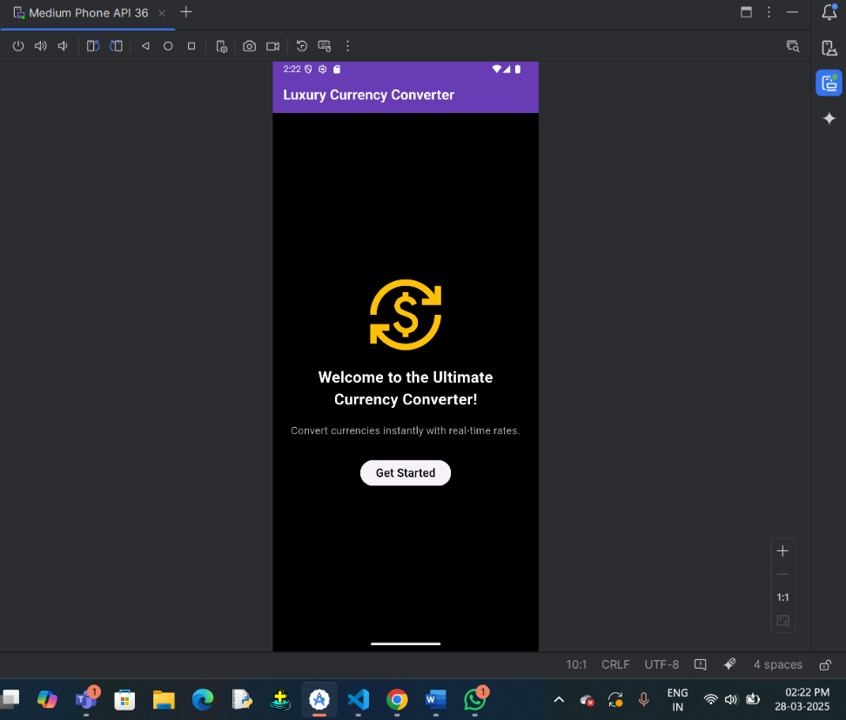

1. CONVERTER SCREEN PAGE

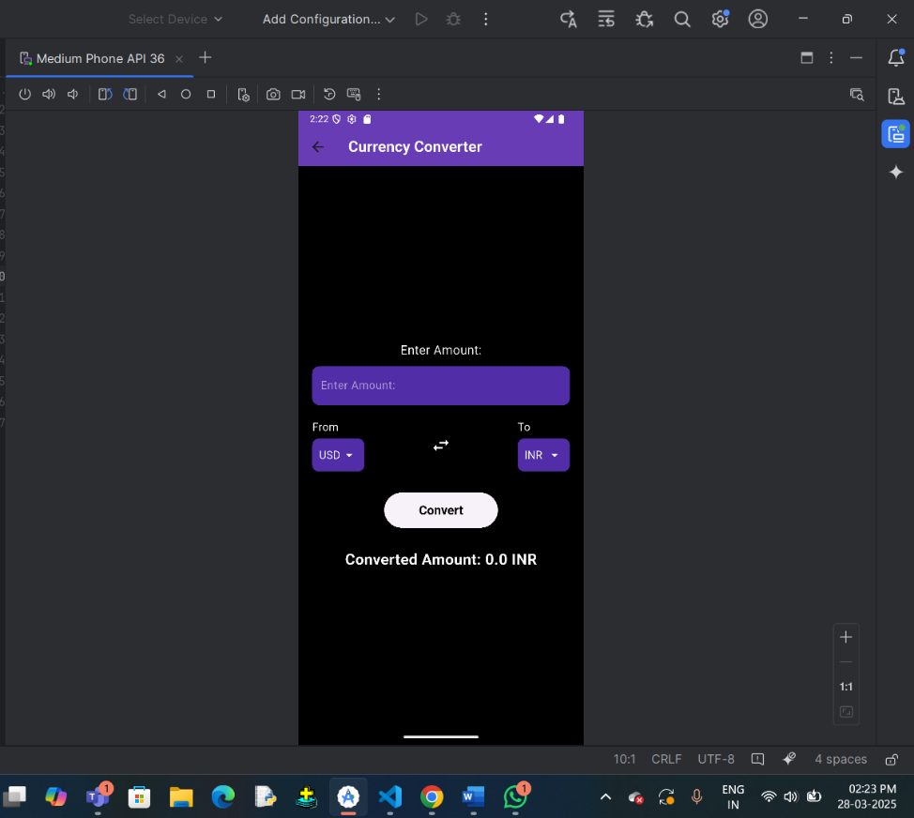

1. ENTERING AMOUNT DETAILS

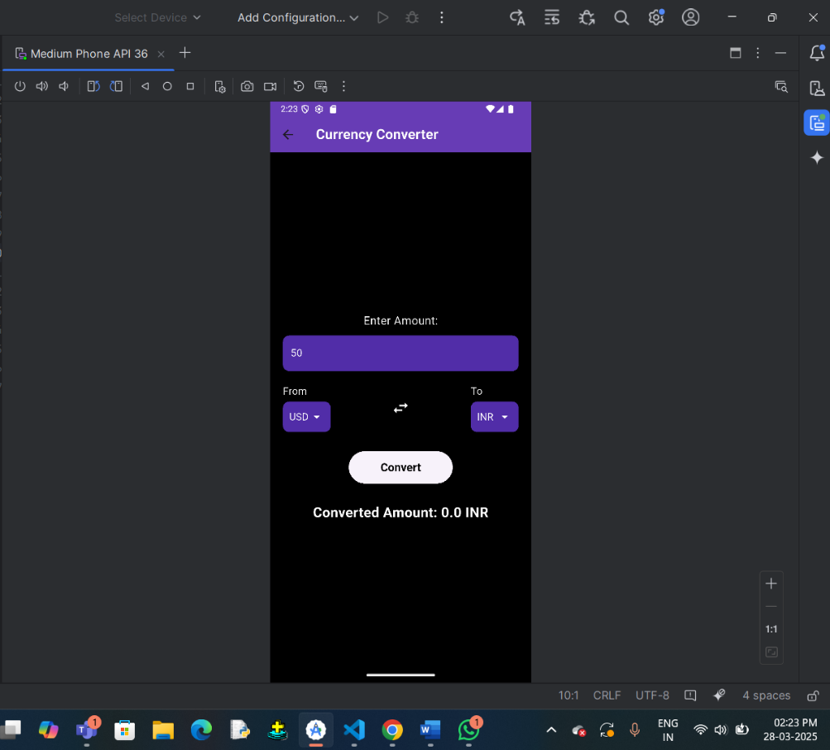

1. CURRENCY TYPE IN DROPDOWN

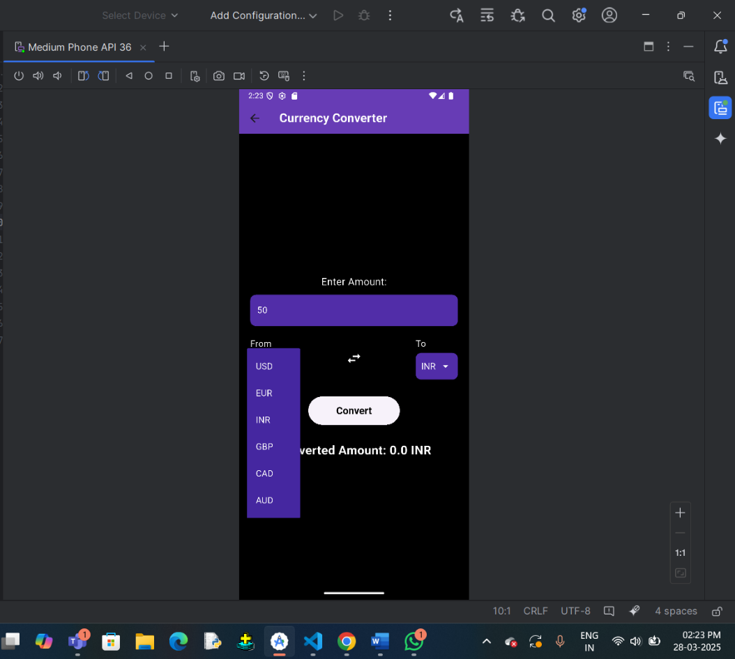

1. CONVERTING THE AMOUNT TO DESIRED CURRENCY VALUE (CONVERSION RATE FETCHING VIA API)

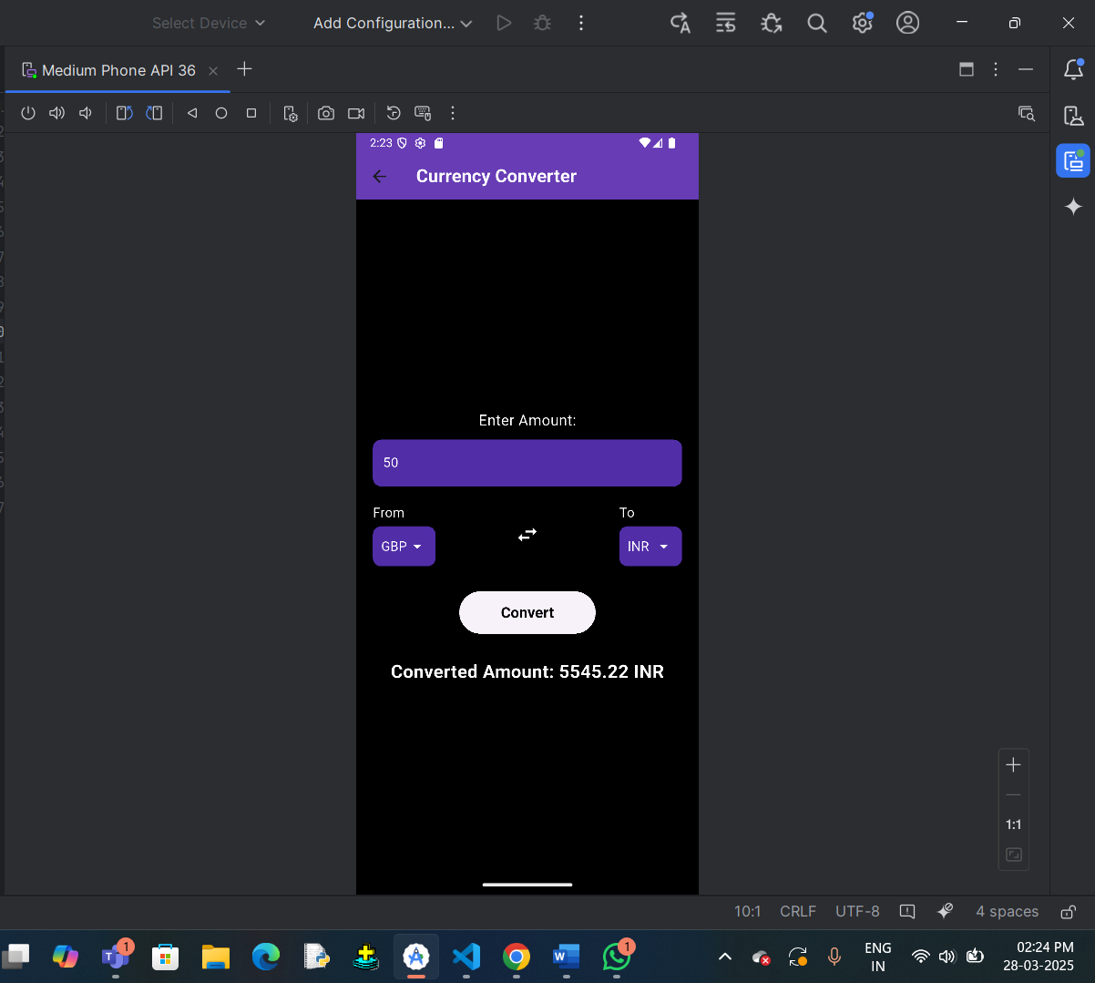

1. LOCALIZATION OF THE APPLICATION

1.SPANISH

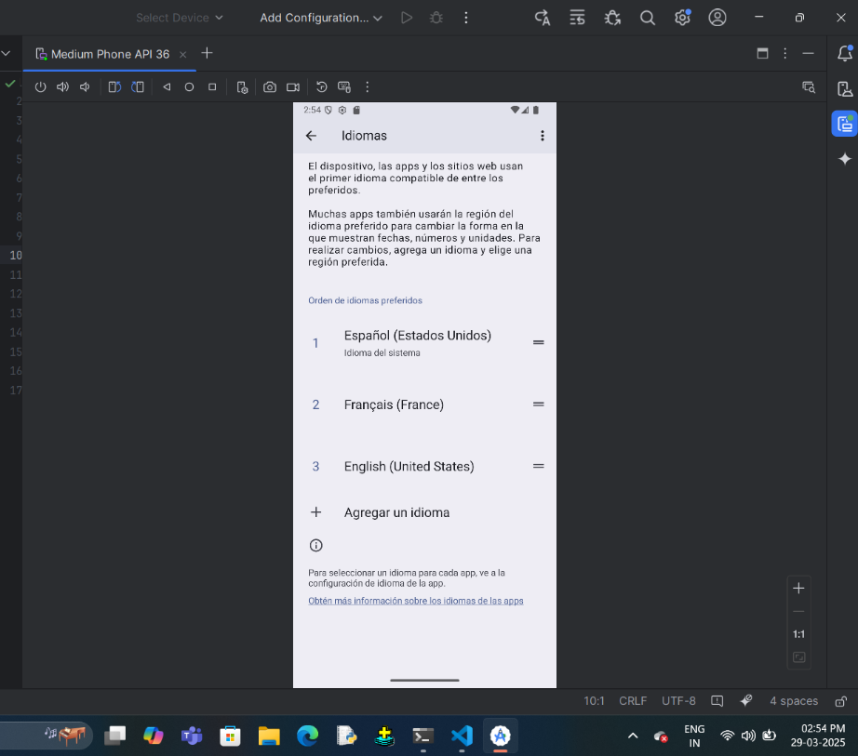

RESULT FOR SPANISH :

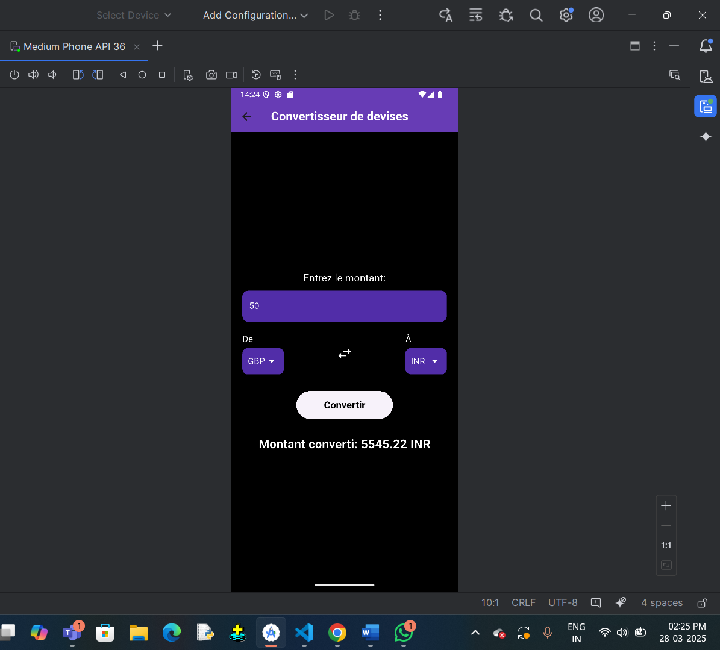

2. FRENCH

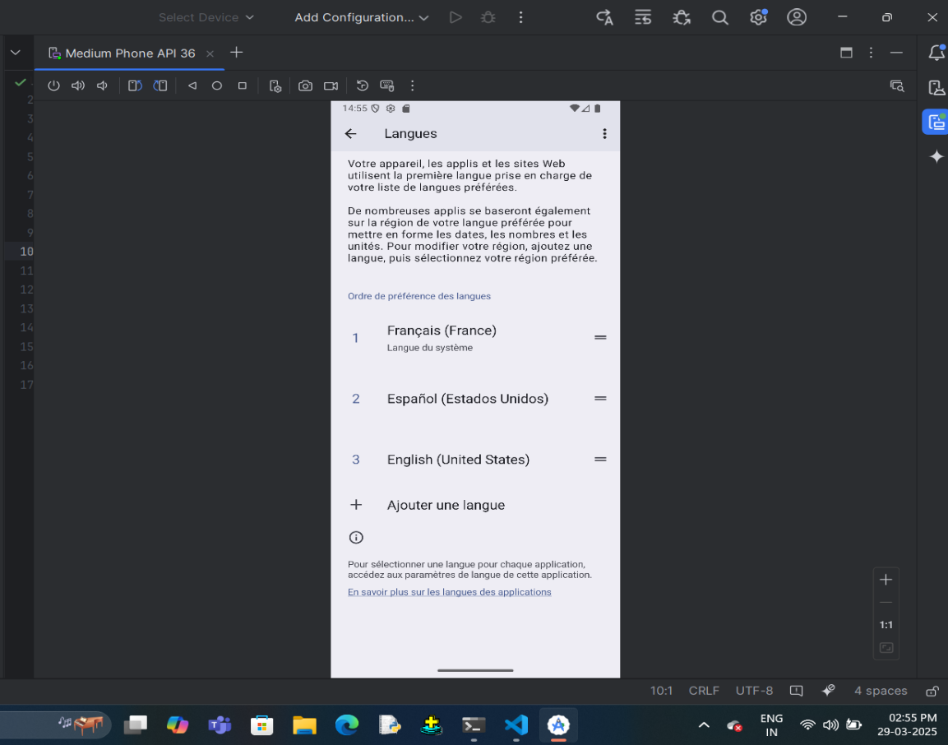

RESULT FOR FRENCH :

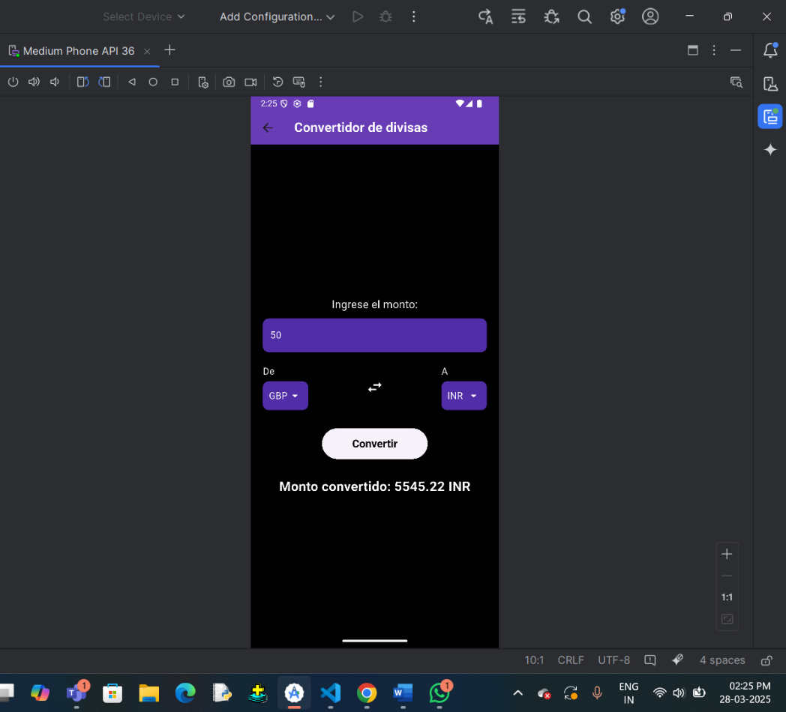

1. FIREBASE CONNECTION TO STORE THE CONVERSION HISTORY

